**Gender pay gap: The Dollar-And-Cents Case:Hidden factors behind the story**

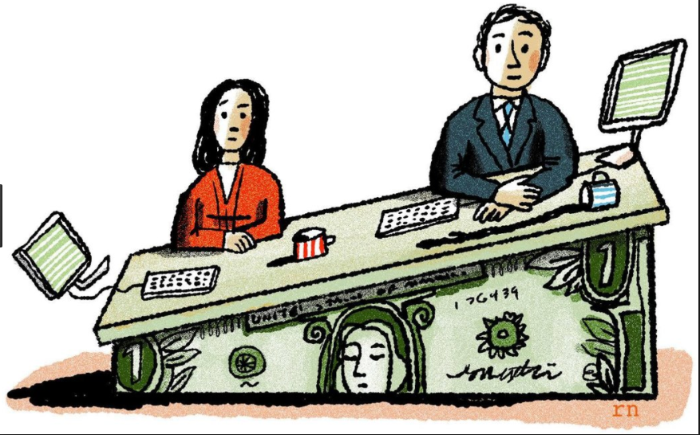

**Presented BY: Purnima Tripathi**

**Mishita AGARWAL**

**SHUYUAN Yang**

**ISHRATH Ayesha AJMAL**

**Yuan CHENG**

**About the project:**

According to an article by Forbes even undergraduate women from Harvard believe that when they are going to earn they will get 78 cents on a dollar compared to men just because they are women. Those women admitted to Harvard can be distinguished from the smartest, most talented and most dedicated of their high school peers but even if they can freak out over the issue, we feel anyone can feel the same. Being a woman dominated group (“in the number of participants”) we are very much concerned that all of our hard work should not become a victim of gender bias if it exists. Here, we found our way to start our analysis of this critical issue of PAY wage gap in the USA.

**Claim:**

Researchers claim that women in the USA earn 78 cents on the dollar compare to men, this story doesn’t hold good for gender bias. Women voluntarily picked up lesser paying jobs and there are fields in which women are earning equally to men in the same profession such as Tennis. There are fields such as entertainment and movies in which women are earning less but it requires critical analysis of genre, screen time, lead role e.t.c. However, we cannot just conclude with one metrics that women are not the victim of discrimination but pay wage gap is certainly a huge issue and we suggest that women right from the early education should boost their Morale to pick up high paid occupations.

**Resources and Tools:**

**Objective:**

**“Women more than men adjust their careers for family life”**

**- Pew research Centre**

According to 2013 survey done by PRC shows that women more likely see career interruptions than men though in 2012 survey 79% Americans denied the notion of women in a traditional role of homemaker.

Though in 2013 many of them did not find a full time working mom as an ideal situation for young Kids.

Even TIME supports above claim by accessing data released by Bureau Of Labour Statistics.

**Overview of no. of men and women in different kind of Occupation:**

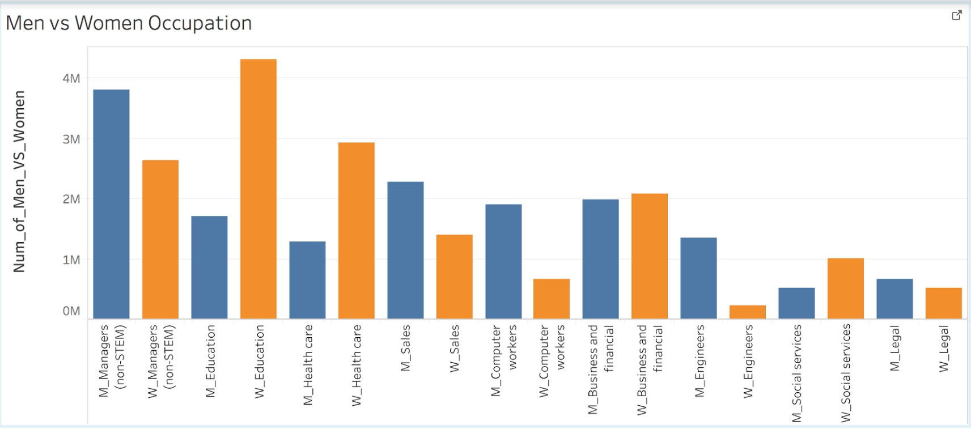

Source: <https://www.census.gov/dataviz/visualizations/stem/stem-html/>

**Claim**: Women prefer non-corporate jobs over corporate jobs whereas men prefer corporate jobs over non-corporate jobs. Corporate positions include engineers, managers, computer workers, etc. Non-corporate positions include jobs in education, healthcare, etc.

**Domain**: The data for the above shown visualization is collected from census.gov. The data set includes fields of degree and occupation of US population in the age group of 25 to 64 years. The data field is further categorized into gender and race. However, since our focus is on comparing the occupations pursued by men and women, we did not consider degrees. We used Excel tools and python for data wrangling and picked the gender wise data for Men and Women occupations.

The other two charts shows the proportion of men and women respectively involved in each occupation.

**Audience**: The main audience for the above visualization is the working population of United States.

**What does this visualization convey?**

The first chart shows the number of men and women in different kinds of occupations. X-axis shows the type of occupations and Y-axis shows the number of men and women in the occupations. This includes several technical, corporate, and non-corporate jobs. Bar graph is used as a visualization tool where blue represents men and orange represents women.

**Goal**: The purpose is to show the distribution of male and female population in various types of occupations. We want to show our audience if there is any field of occupation in which one of the genders dominates the other. If yes, what are the reasons behind it.

**Why this is important**: To understand the theory of gender pay gap, it is very important to know the overall breakdown of men and women population in various kinds of occupation. A person’s pay depends on the type of occupation s(he) is in. Also, within an occupation, a person’s pay is dependent on his/her position in the job hierarchy. For example, entry level workers are paid significantly less than executives.

As seen in the above visualization, women are predominantly employed in education, health sector, business whereas men are predominantly employed in engineering, management, computing, etc.

We want on to analyze reasons behind it:

**Warrant:** Corporate culture signifies time-bound executions, deadlines, work pressure, round the clock involvement into projects and, hence, is much more demanding in terms of time and availability. Women usually being primary home-maker and secondary earning member of the family need to make a fine balance between their work life and home making which is much harder to achieve in corporate jobs than non-corporate ones. For example, a woman working as a teacher in a school can devote her time to her family much more easily than a woman working as a corporate executive. The above visualization shows that there are more male managers than women managers. If we observe the above visualization, we can clearly see the difference between men and women in occupations such as managers, education and healthcare.

As mentioned in the article, women find managerial positions less desirable and the female managers sometimes have low satisfaction level than male managers. **Why is it so?**

**The article snippet[figure 1] mentions the following reasons:**

1.Women have higher number of life-goals than men and give more importance to keep balancing their work-life schedule rather than to earn prestige and money, which they can achieve by holding top positions.

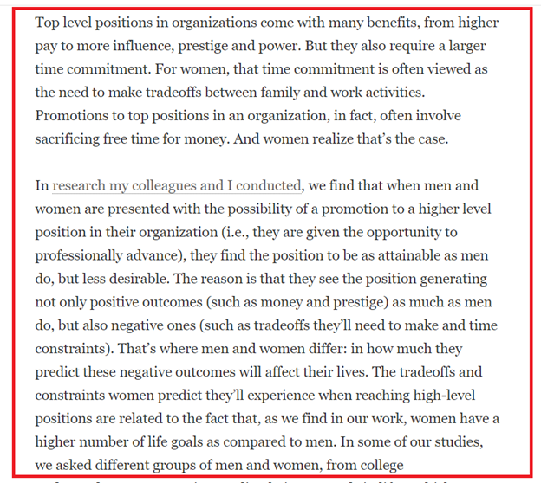

**Figure 1** Why women may find management jobs less desirable. Data source: <https://www.scientificamerican.com/article/women-may-find-management-positions-less-desirable/>

The article snippet shown in Figure 2 also lists the reason behind high number of women taking up healthcare and education jobs. It says that women by their nature are more caring than men. Which is why we are seeing lot of women engaging in jobs such as baby sitter or elder care taker.

However, some women may turn to teaching and healthcare jobs because of discrimination in their work-settings, and therefore, they tend to pursue their career in the job that emphasizes on care and engagement, even if they pay less as compared to other jobs.

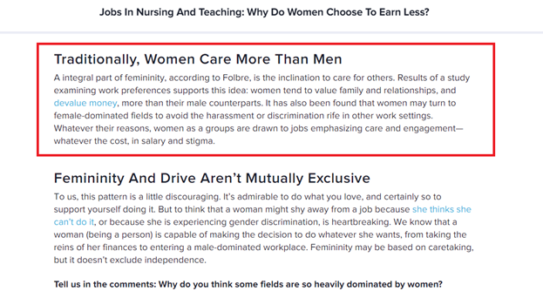

**Figure 2:** Why do women chooses job in nursing and teaching.

**Data source:** [**https://www.learnvest.com/2010/08/jobs-in-nursing-and-teaching-why-do-women-choose-to-earn-less**](https://www.learnvest.com/2010/08/jobs-in-nursing-and-teaching-why-do-women-choose-to-earn-less)

Now after looking at several male dominated occupations, if we look at the “business and financial” occupation, surprisingly women are slightly higher in number than men.

Business and financial occupation cannot be put in either of the bucket (corporate or noncorporate), it lies somewhere in between the two and consists of jobs like small businesses, medium businesses, investment banking, etc.

The article snippet [figure 3,4] shown below indicates that, as of 2012, USA has around 9,878,397 women owned businesses and out of these businesses, around 90% have no employees other than the owner. This clearly, explains the reason behind the large concentration of women in business and financial occupations.

1. Women engage in business and financial occupations because, they can enjoy time-flexibility and as majority of them are handling their business single handedly, they can manage their work-life balance more easily as compared to other corporate jobs, where a person must regularly report to his/her manager or handle his/her subordinates.

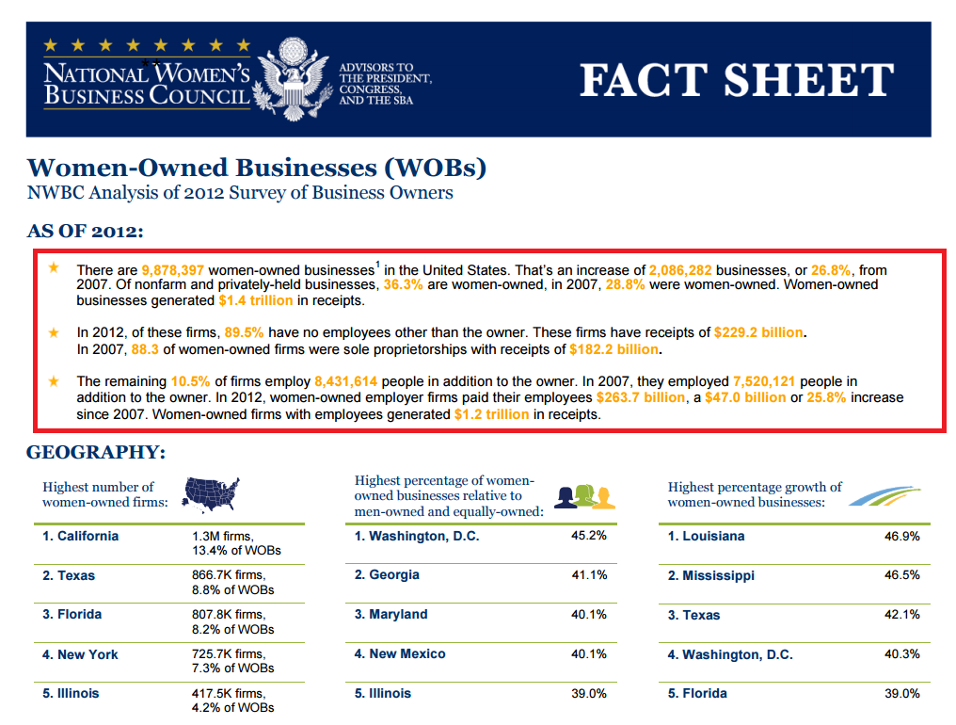

**Figure 3**: Women in business-financial occupations.

**Data source:** [**https://www.nwbc.gov/sites/default/files/FS_Women-Owned_Businesses.pdf**](https://www.nwbc.gov/sites/default/files/FS_Women-Owned_Businesses.pdf)

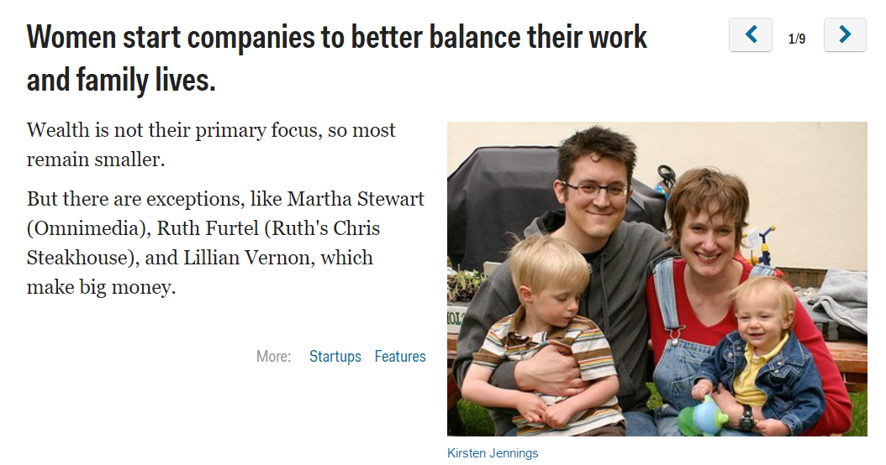

**Figure 4: Women in small businesses.**

**Data source:** [**http://www.businessinsider.com/battle-of-the-sexes-do-men-or-women-make-better-entrepreneurs-2010-11#women-start-companies-to-better-balance-their-work-and-family-lives-1**](http://www.businessinsider.com/battle-of-the-sexes-do-men-or-women-make-better-entrepreneurs-2010-11#women-start-companies-to-better-balance-their-work-and-family-lives-1)

All the articles shown above provide us a valuable insight that why women are concentrated more in education and health care jobs. Even the jobs such as **“business and financial”**

which have a higher share of women is because self-owned businesses though comes with a huge responsibility provides a decent time flexibility to women as compared to engaging in other occupations such as management, sales,etc and they can manage their work-life balance more easily by engaging in these occupations.

**Rebuttal:**

**About Education industry:**

The above shown articles explain that women choose non-corporate jobs especially education because they are more flexible as compared to other jobs. So, does it imply that these jobs are not challenging and it’s quite easy to fulfil job responsibilities in them.

**The answer is no**, teaching jobs are in fact very challenging and there are several reasons behind the large female concentration in this sector.

These article [ figure5] clearly, shows that there are lots of responsibilities and burden

1. Though the time duration is less for teachers as compared to other corporate occupations, teachers must stay in the school later after the students left.

2. The job is not only confined to teaching the syllabus but teachers are also responsible for the students’ overall development, because students consider as their role models.

3. It requires a lot of patience to deal with students especially toddlers. It is certainly not an easy task for women to manage kids with so much patience while maintaining the energy for the whole day. This also is a reason behind less number of men in education jobs.

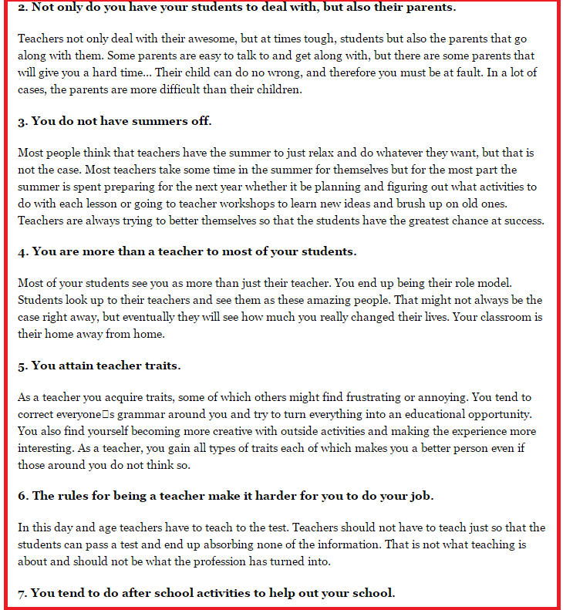

Figure 5: Challenges in a teaching jobs

Data source: <https://www.theodysseyonline.com/teacher-hardest-rewarding-careers>

**About Health Care industry [figure 6]**

**Secondly,** although, the above visualization shows that %age of women (14.01%) is higher in healthcare as compared to Men (6.23%), this does not necessarily mean that, this holds true for all the professions in the healthcare field. The following visualization shows that compared to women there are more men doctors, physicians, and surgeons in most of the specialties.

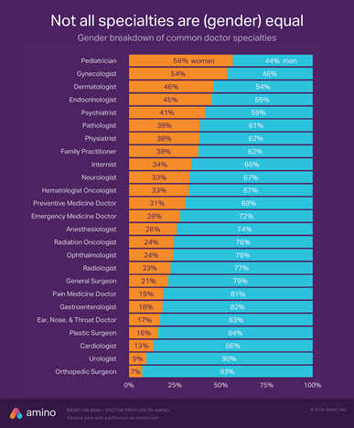

**Figure 6:** Engagement in Doctors specialities by gender

**Data source:** [**https://amino.com/blog/how-the-gender-gap-is-shifting-in-medicine-medical-specialties-by-gender/**](https://amino.com/blog/how-the-gender-gap-is-shifting-in-medicine-medical-specialties-by-gender/)

However, women constitute a gigantic 94.2% chunk of the nursing jobs as shown in the subsequent figure [ figure 7]. This explains the higher number of women in healthcare occupation than men.

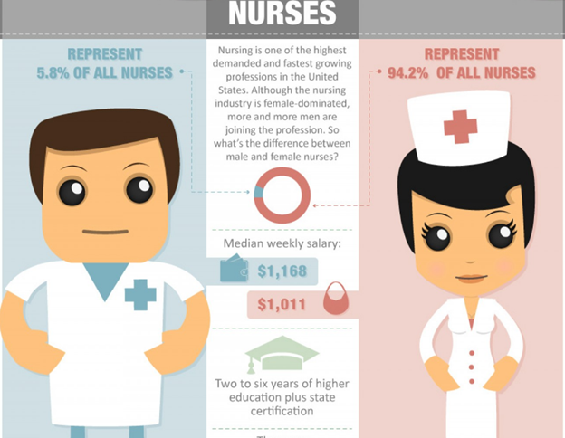

**Figure 7:** Men vs Women in Nursing occupation.

Data source: <https://visual.ly/community/infographic/health/male-vs-female-nurses>

As seen from the figure 7 above, despite being a meagre 6% of the total nursing employees, men have more per capita earnings than women. The below snippet of the article [figure 8] provides us a reason:

The reason is there are more male anesthetists than female and median earnings of nurse anesthetists is more than twice the average earnings of overall nursing occupation. This explains the reason that despite of fewer men in nursing, they earn more than women.

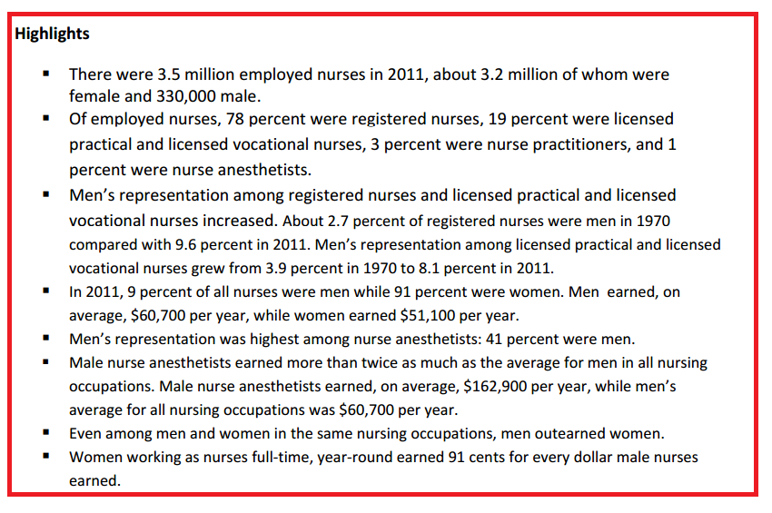

**Figure 8:**

**Data source:** [**https://www.census.gov/people/io/files/Men_in_Nursing_Occupations.pdf**](https://www.census.gov/people/io/files/Men_in_Nursing_Occupations.pdf)

**Conclusion:**

After seeing all the visualizations and various articles, it is evident that the above claim holds true. There could be several factors in deciding the income of any person, but certainly one very big factor is the choice of occupation. We see above, that women are lesser in management jobs and even in non-corporate jobs such as healthcare, they are more engaged in nursing jobs instead of other doctor’s specialties such as Surgeons and Urologists. Therefore, choice of occupation matters a lot and along with that it is very important that in which particular stream a person is working.

**Ayesha)**

**Average hourly pay in these occupation:**

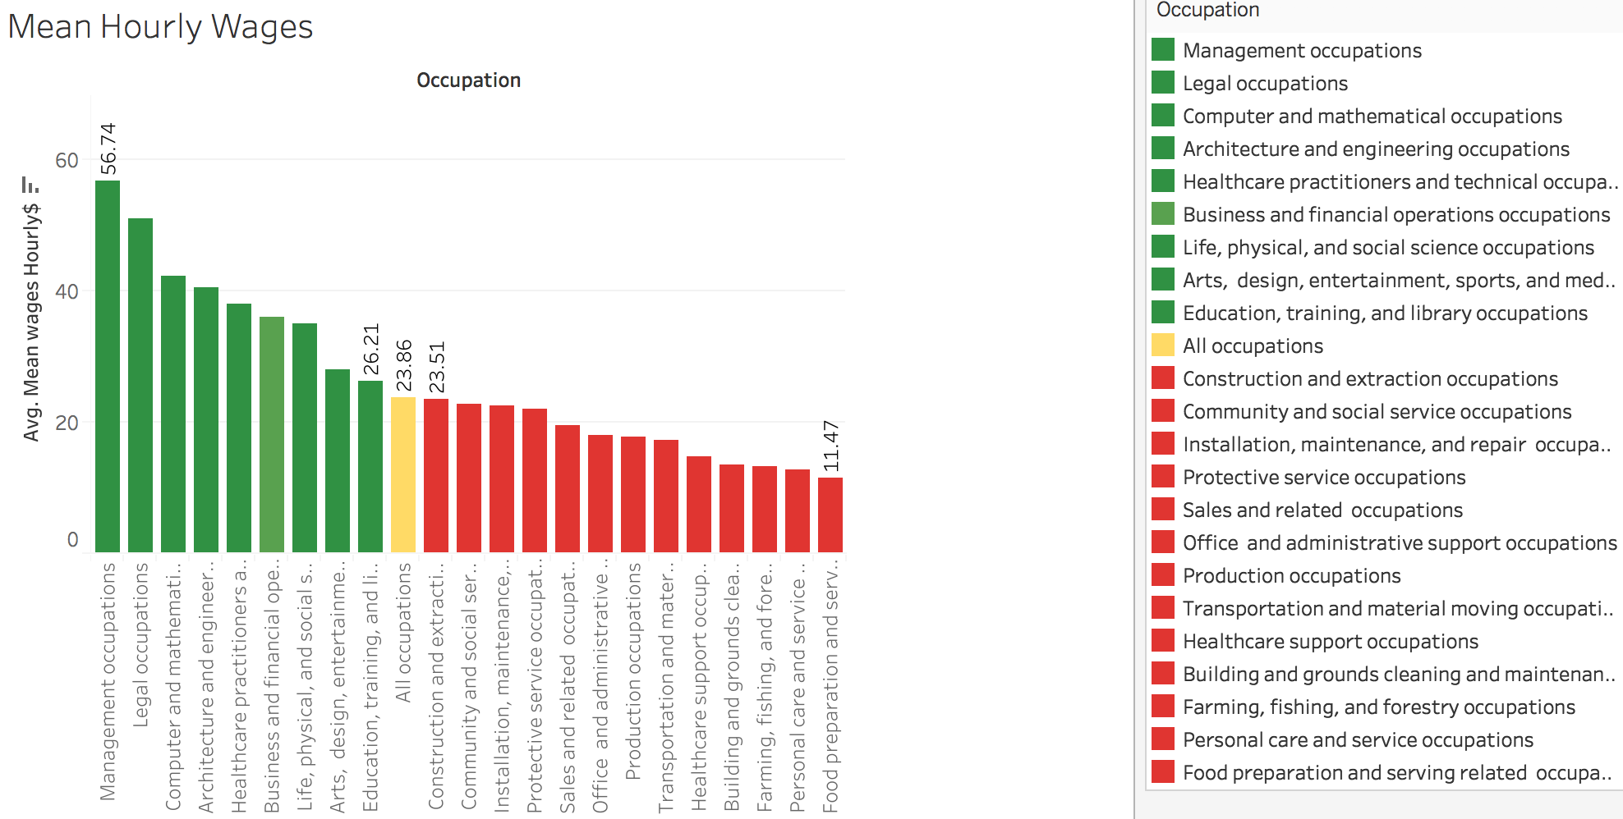

Data Source : Bureau Of Labour Statistics

The above data was taken from the Bureau of Labour Statistics (<https://www.bls.gov/news.release/pdf/ocwage.pdf>) This chart’s purpose is to show some of the major occupations categories and their respective average hourly wages. The details about the what occupations come under each category are given in detail in the BLS news release. For the purpose of this project we decided to study the major categories of occupations and the respective hourly mean pay. From the chart we can see that the occupation category with the most pay is under the ‘Management’ classification of jobs with an average hourly pay of about 56.74$ which is more than twice the overall average pay (23.86$). The lowest average pay is for ‘Food Preparation and Serving’ classification while the ‘Education, training & library occupation’ and ‘Construction & extraction occupations’ have a little higher and lower pays at 26.21$ and 23.51$ respectively.

We wanted to showcase this chart to get an idea of what occupation pays how much without trying to see any sort of gender distribution in them. The reason being, we wanted to use this information to see whether women were taking up jobs in those industries where the pay itself is simply lower than the overall average pay. In such jobs, regardless of gender discrimination, women would anyways be getting a far lesser amount. If more women than men were pursuing jobs in the red side of the chart then the pay gap will only increase regardless of the additional gender discrimination factor that are in play.

**(Purnima)**

**Where they are getting paid equally-sports**

**(Purnima)**

**Where they are not getting paid equally(Hollywood movies)**

Data source: <http://time.com/money/4207416/hollywood-wage-gap/>

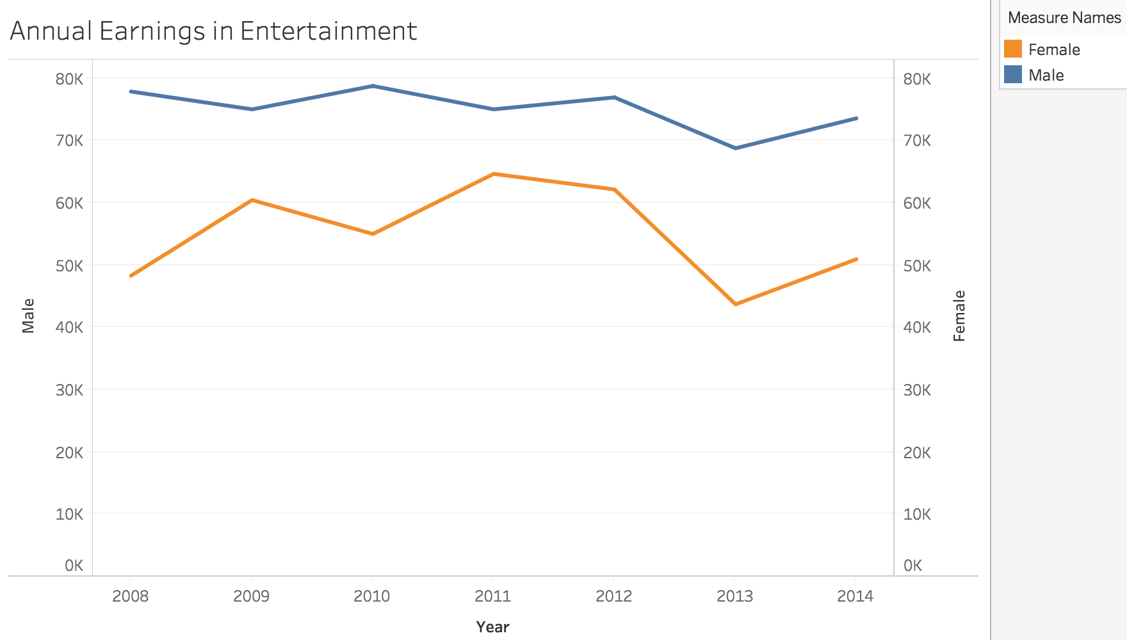

**Data Source**

**Writers Guild of America, West (WGAW); Women's Media Center**

**Survey by**

**Writers Guild of America, West (WGAW)**

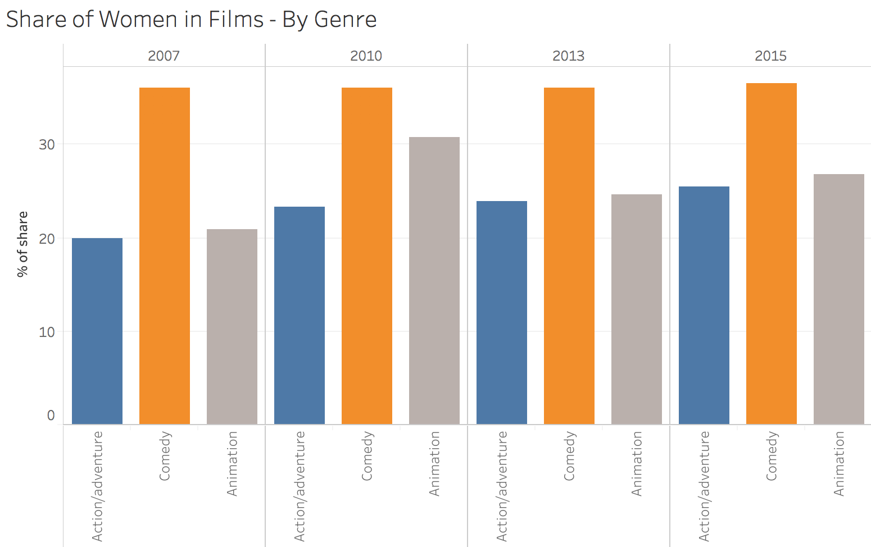

**Data Source : MDSC Initiative**

**Survey by : MDSC Initiative**

**(Sherry)**

**Right/Wrong choices of jobs for Women**

Data source: <http://money.cnn.com/2016/03/23/pf/gender-pay-gap/index.html>

Men still make more than women in most professions -- considerably more in some occupations than others, according to a new study by the job search site Glassdoor.

The study, based on more than 500,000 salary reports from its users, compared the pay of men and women with the same job title, at similar companies, in the same state, with similar levels of education and experience. Even after making this apples-to-apples comparison, though, women still get paid less, earning on average about 95 cents for every dollar their male colleagues were paid, according to Glassdoor.

In every industry, women are paid less on average than men for doing the same work — but that isn't to say men out-earn women in every occupation.

If you want to try to narrow the pay gap between women and men, being a woman, there are some professions, you should try to avoid or try to consider.

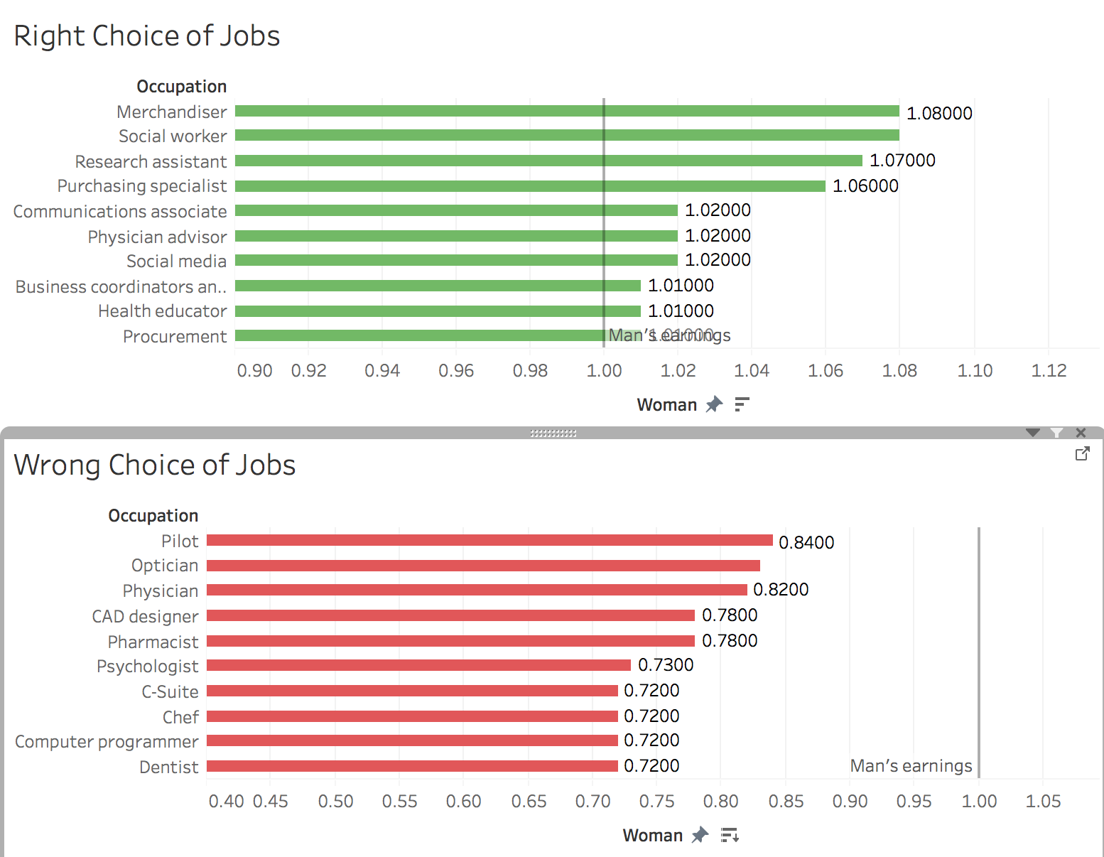

**Warrant:**

According to Forbes Ultimately, men remain the top earners in America, on average and by occupation. Men also hold the majority of leadership positions. Women are just 3% of chief executives at the largest 1000 U.S. companies.

<https://www.forbes.com/sites/jennagoudreau/2011/03/14/jobs-where-women-earn-more-than-men/2/#65df1946dec1>

According to Business insider:

In some instances, based on the job held, the gender pay gap shrinks to a base pay difference of 0.2%, and women earn virtually the same amount as men. And in very few instances the gender pay gap is actually reversed.

<http://www.businessinsider.com/the-only-jobs-where-women-earn-more-than-men-2016-4/#-1>

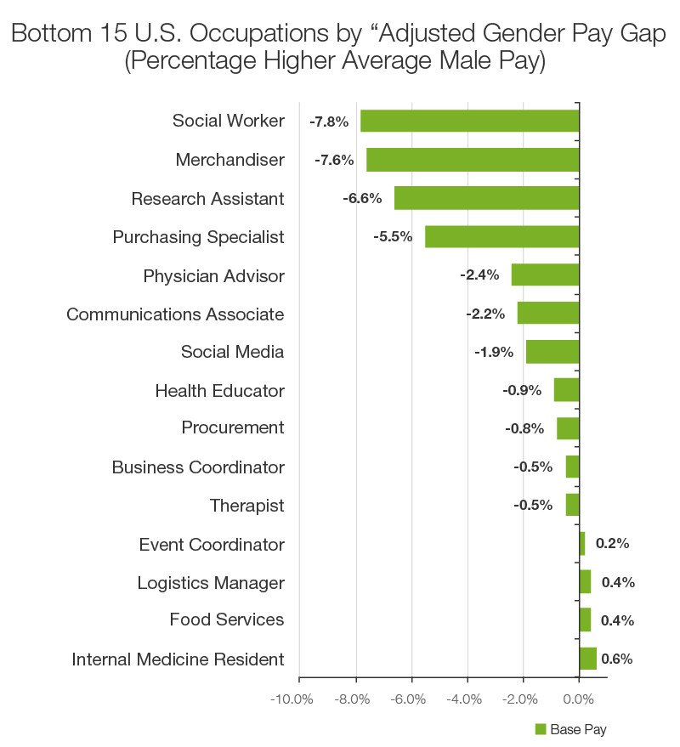

**Backing:**

These women-make-more professions are female dominating and are more flexible to ask for a leave. Women intend to choose these professions to work as well as taking care of the family.

Rebuttal:

According to INVESTOPEDIA:

When considering the significance of any pay gap, the pay rate in occupations also needs to be considered. When a male computer programmer earns an adjusted 28.3% more than a woman programmer (as the Glassdoor study found), the bonus in his paycheck will be a lot bigger in real dollars than that of a woman social worker who earns 7.8% more than her male counterpart.

<http://www.investopedia.com/articles/personal-finance/010717/10-jobs-where-women-earn-more-men.asp>

**Conclusion:**

Although women-make-more list is refreshing, it’s true that the pay gap is much more significant in the roles for which men are paid more — for instance, topping that list is “computer programmer,” for which women earn $0.72 for every dollar men make.

The largest contributing factor is something called industry sorting. Women make up only 26% of highly paid chief executives but 72% of lower paid jobs like cashiers. Previous research, according to the Glassdoor study, suggests that this is partly due to social pressure that sorts women and men into different college majors and career tracks. Additionally, women tend to take on a larger share of child and elder care, causing them to look for jobs with more flexible schedules – which come with lower pay. The study found that the discrimination itself, age and experience are a much smaller factor in pay inequality. Making affordable child care and elder care more accessible could help even the playing field for men and women so that women can have the freedom to choose more professions.

The ultimate goal is to live in a world where men and women make the same amount of money for the same amount of work, no matter what field they choose to pursue.

**Critical Analysis:**

**References:**

1. <https://research-content.glassdoor.com/app/uploads/sites/2/2016/03/Glassdoor-Gender-Pay-Gap-Study.pdf> Demystifying the Gender Pay Gap
2. <http://www.investopedia.com/articles/personal-finance/010717/10-jobs-where-women-earn-more-men.asp> 10 Jobs Where Women Earn More Than Men

# <http://www.businessinsider.com/the-only-jobs-where-women-earn-more-than-men-2016-4/#-1> These are the only 11 jobs in the US where women earn more than men

1. <https://www.forbes.com/sites/jennagoudreau/2011/03/14/jobs-where-women-earn-more-than-men/2/#65df1946dec1> The 15 Jobs Where Women Earn More Than Men
2. <http://money.cnn.com/2016/03/23/pf/gender-pay-gap/index.html> Yes, men earn more than women. Except in these jobs
3. <https://www.bls.gov/news.release/pdf/ocwage.pdf> - Average Hourly Wages
4. MDSC Initiative. *Share of women in films in the United States from 2007 to 2015, by genre*. <https://www-statista-com.libproxy.scu.edu/statistics/641275/film-gender-distribution/> (accessed June 6, 2017).
5. Women's Media Center. *Annual earnings of people in film in the United States from 2008 to 2014, by gender (in U.S. dollars)*. <https://www-statista-com.libproxy.scu.edu/statistics/696543/film-annual-earnings/>

(accessed June 6, 2017).